Contents

Project GitHub link: 1

https://github.com/xeno1211/Project 1

Project Design Document 1

Risks 1

Out of Scope 2

Estimates 2

Screenshots: 2

New User UI 2

Login UI 2

Home Page UI 2

All Users UI 3

Create Loan UI 3

All Loan UI 3

Loan Flowchart 4

User Flowchart 5

Create User Postman 6

List Users Postman 7

Protected 7

Create Loan Postman 8

List Loans Postman 9

# Project GitHub link:

# <https://github.com/xeno1211/Project>

# Project Design Document

## Risks

Right now, the application is pretty unsecure. While the passwords are hashed and salted, there needs to be more authentication using HTTPS and OAuth. Right now, it just uses application security, but a bad actor could easily crack the system, especially since the passwords are so weak in the database.

## Out of Scope

I dithered a bit with restricted elements, but I didn’t delve any deeper than what we did in earlier modules. Like I stated above, the code is one thing, but it needs to be secured and hardened. It’s currently pretty unsecure and would need to be secured prior to any real-world deployment. Another out of scope item was making it look good. As I stated in my demo video, I’m not a designer so things like CSS and visual design are not my fortes.

## Estimates

It looks me, a single developer about 10 hours to write the code, based off of previous assignments. I would say it would take someone twice as long (at least) to secure and harden the application prior to deployment. Of course, we’d also need a UX designer to come in and make it look pretty and usable as well.

# Screenshots:

## New User UI

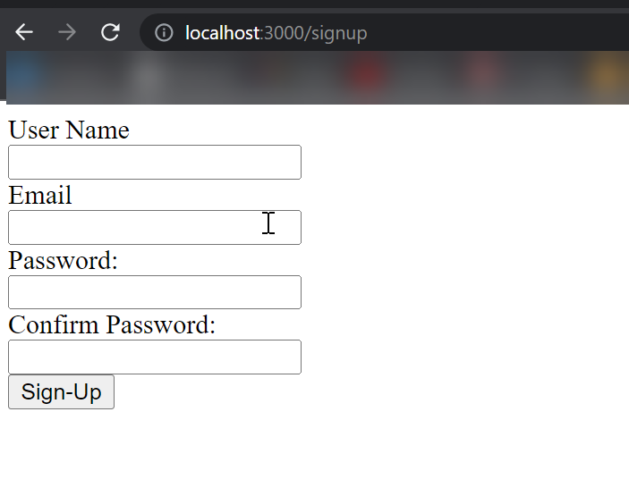

## Login UI

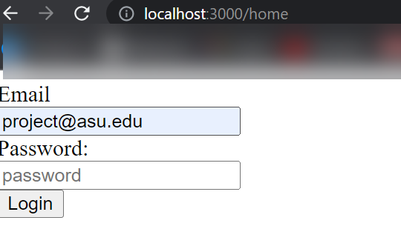

## Home Page UI

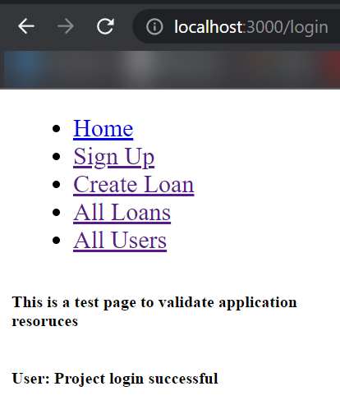

## All Users UI

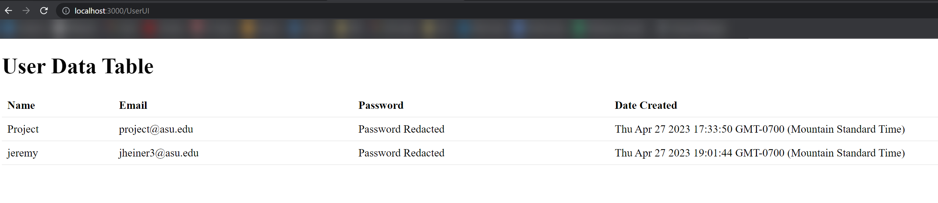

## Create Loan UI

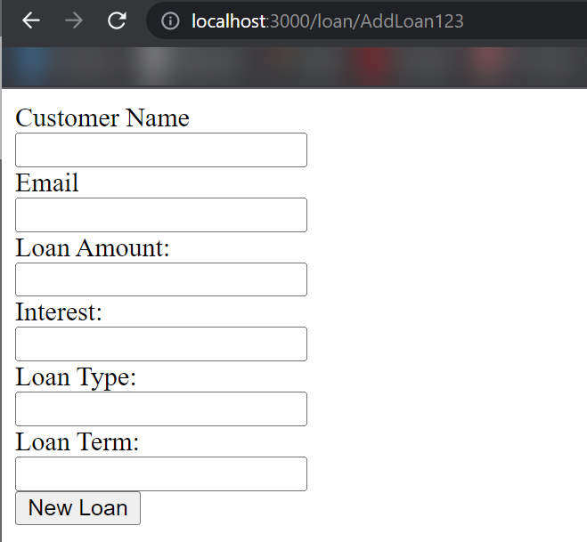

## All Loan UI

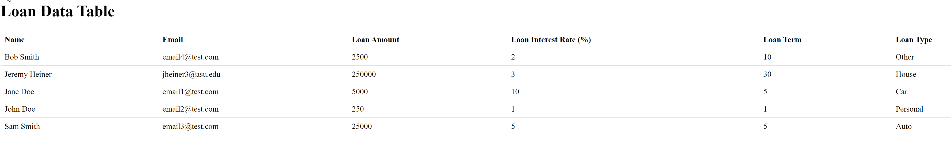

## Loan Flowchart

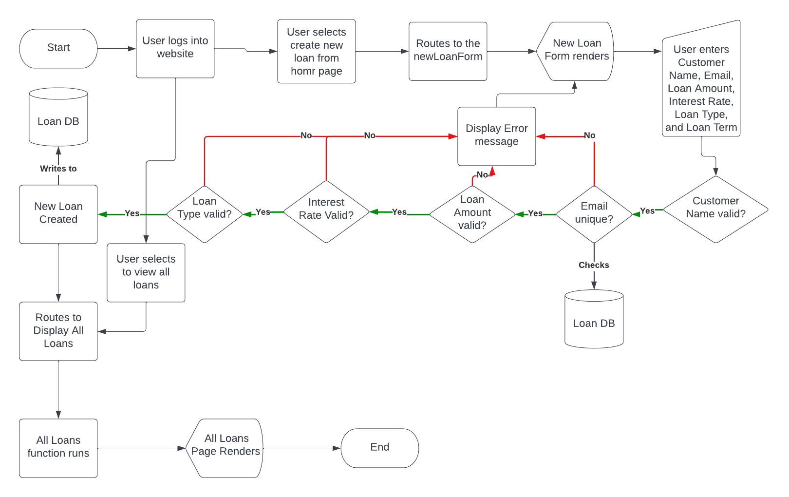

## User Flowchart

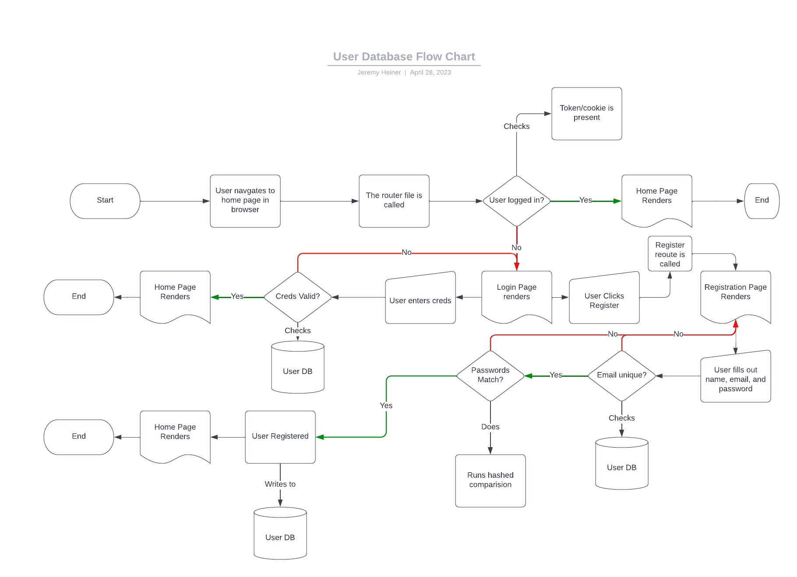

## Create User Postman

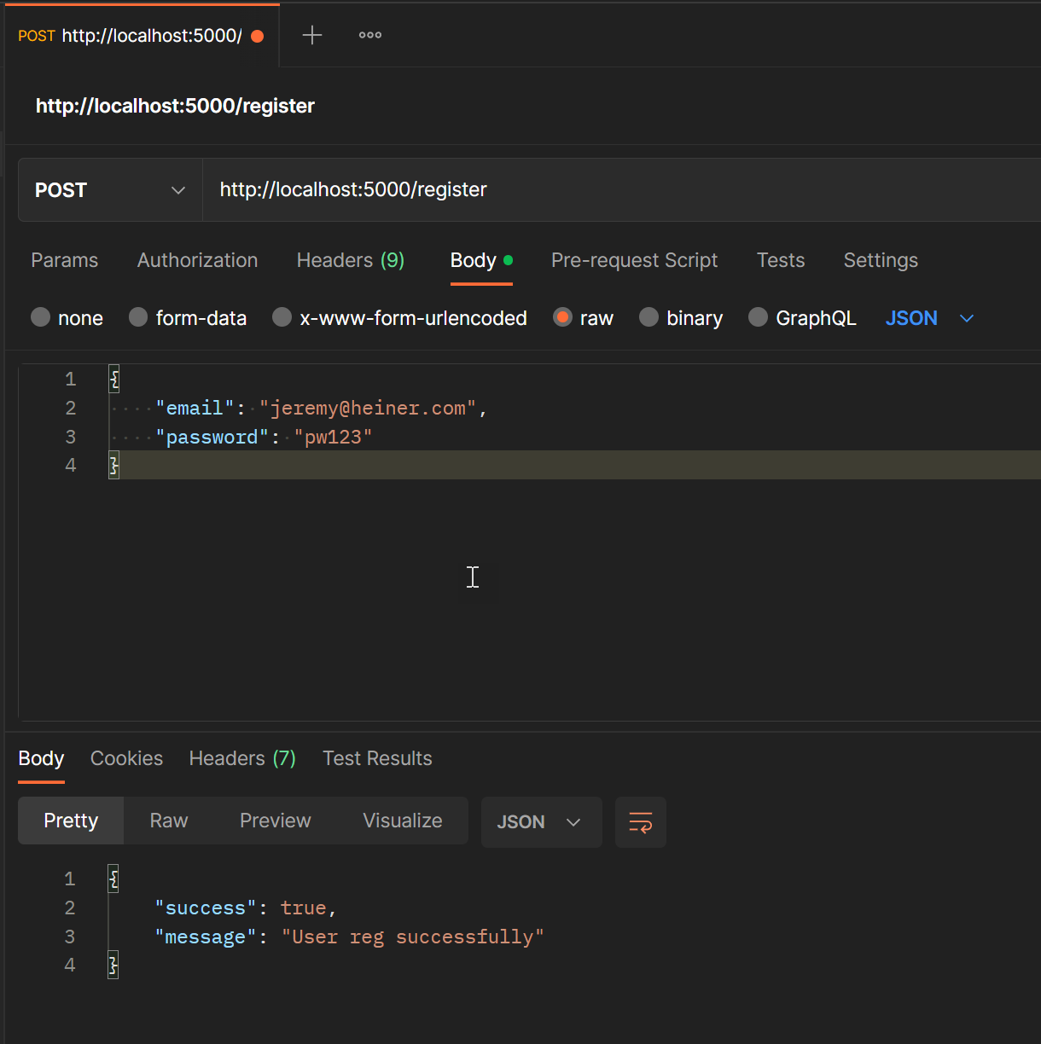

## List Users Postman

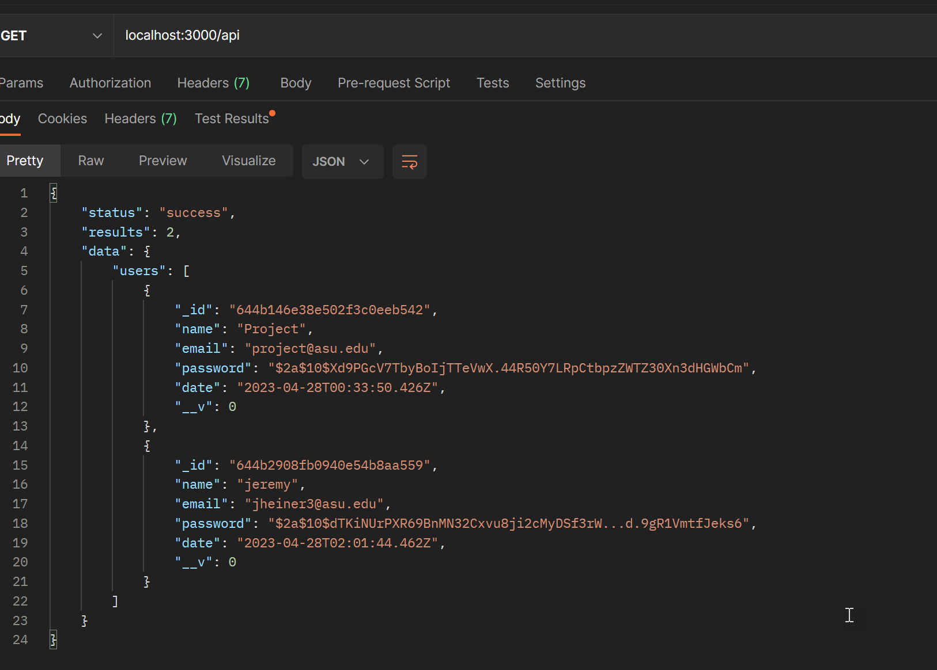

## Protected

Admin User

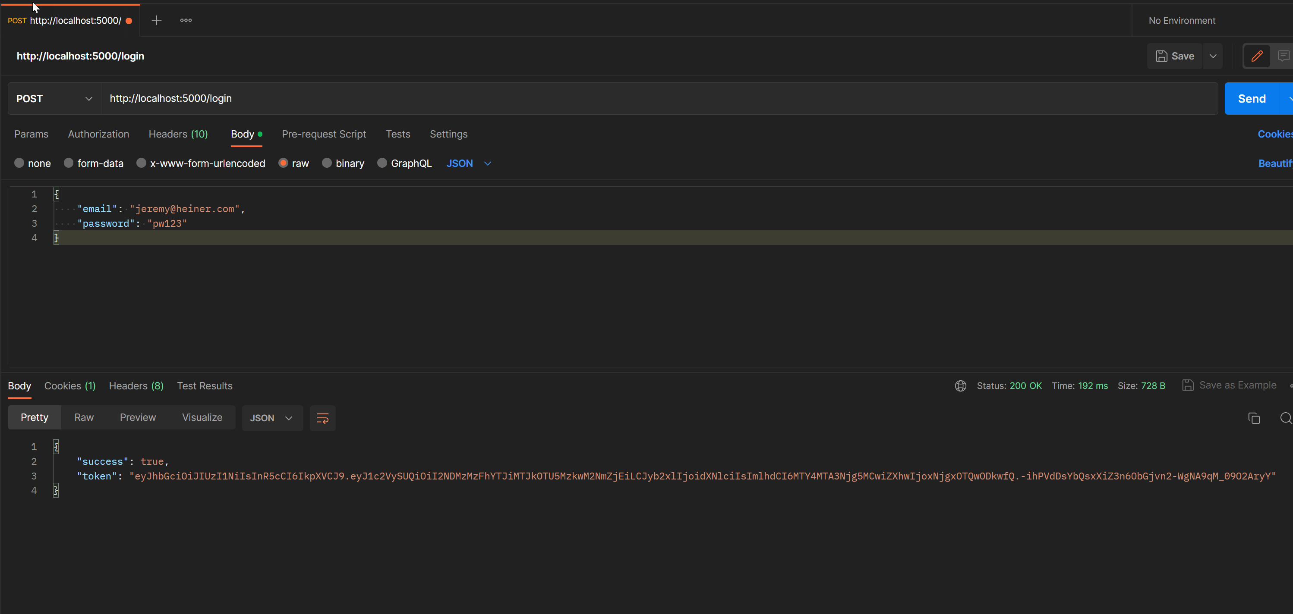

## Create Loan Postman

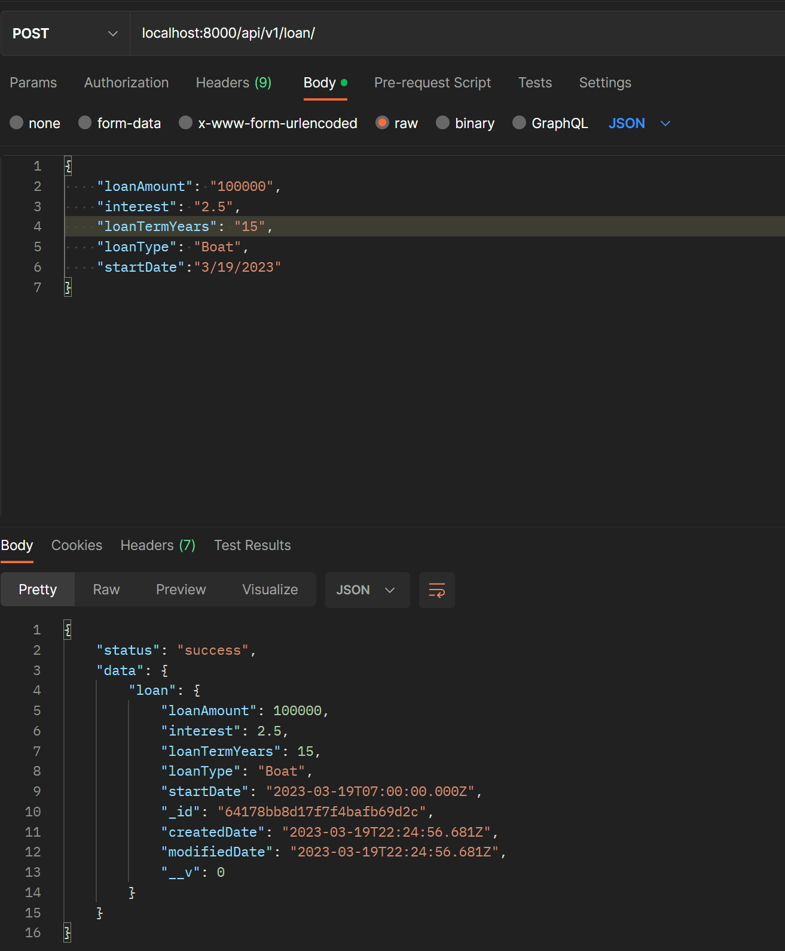

## List Loans Postman

